User Manual

By

Sam W.

Michael W.

User Mode

1. Starting the search engine
   1. 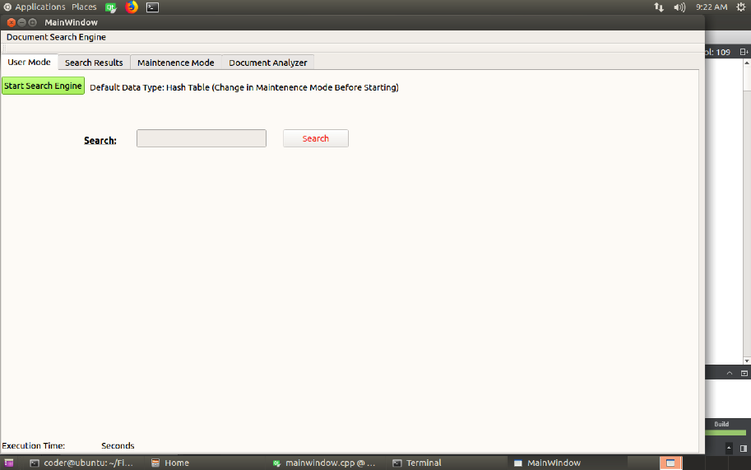
   2. Open the program up to the start screen
   3. 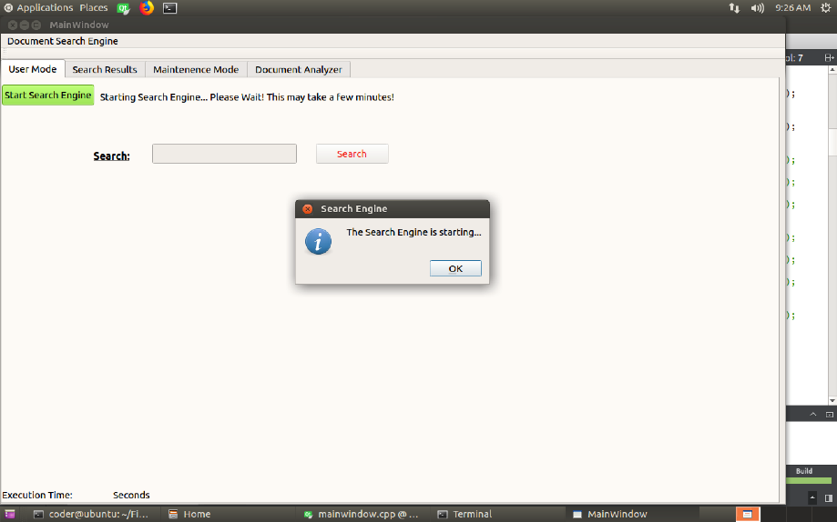
   4. Click the green “start search engine” button (This may take more than thirty minutes)
   5. 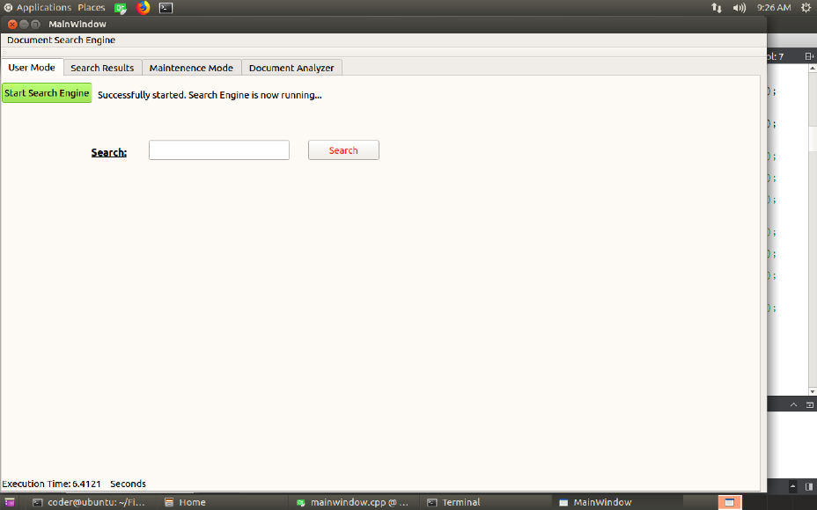
   6. Now that search bar has turned white, and an execution time has appeared in the bottom left hand of the screen, you can type a phrase into the search engine
   7. 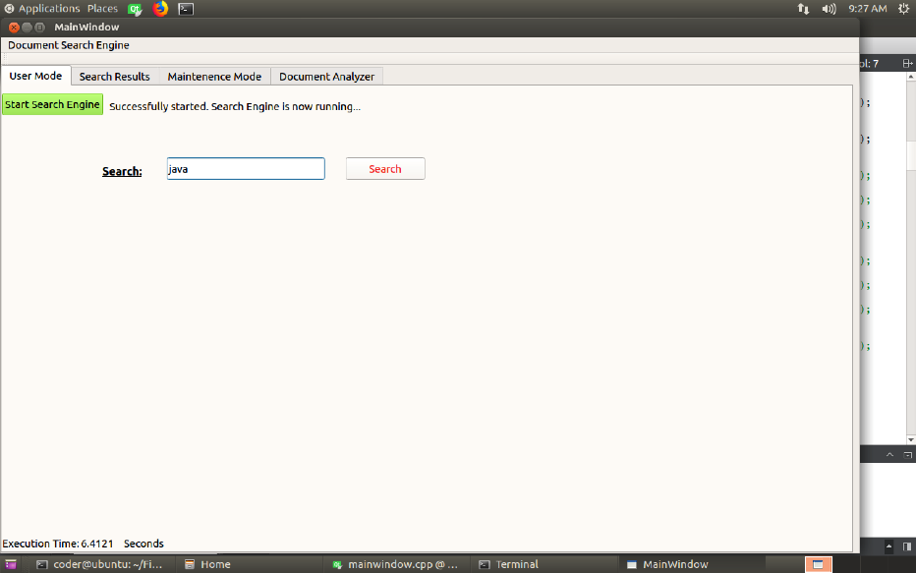
   8. After typing your phrase of choice into the search bar, hit search and wait for results to pop up on the screen
   9. 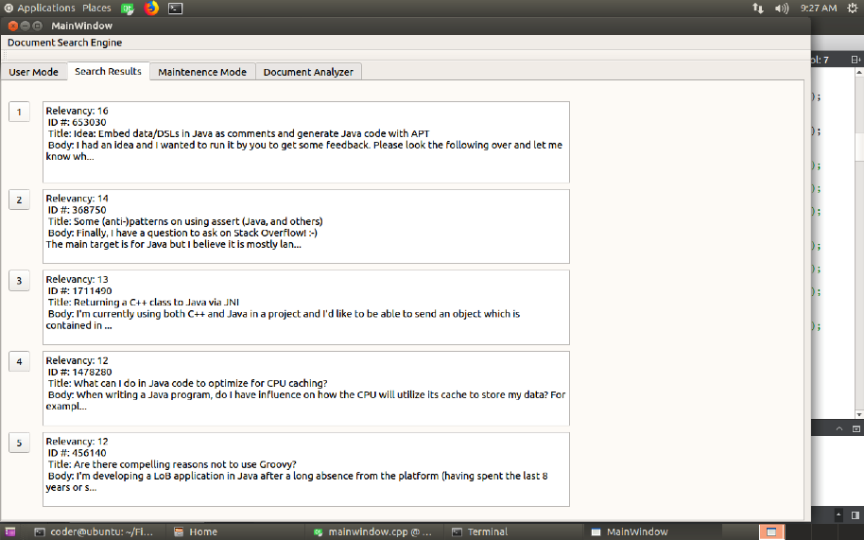
   10. After results have been shown, you may click the numbered boxes on the screen in order to get more information on the document next to it
   11. 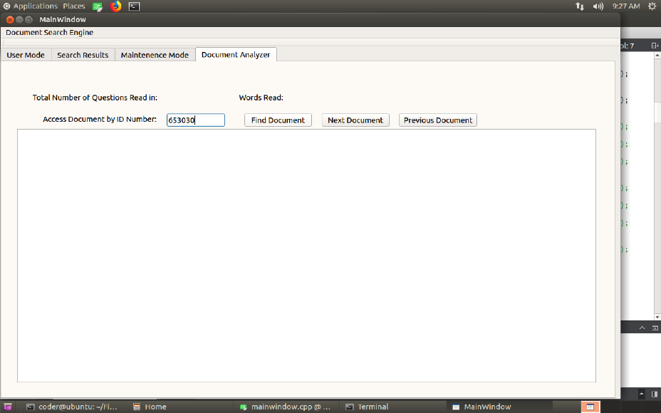
   12. Clicking on the box takes you to the document analyzer screen with the ID number of the document you clicked in the access bar
   13. 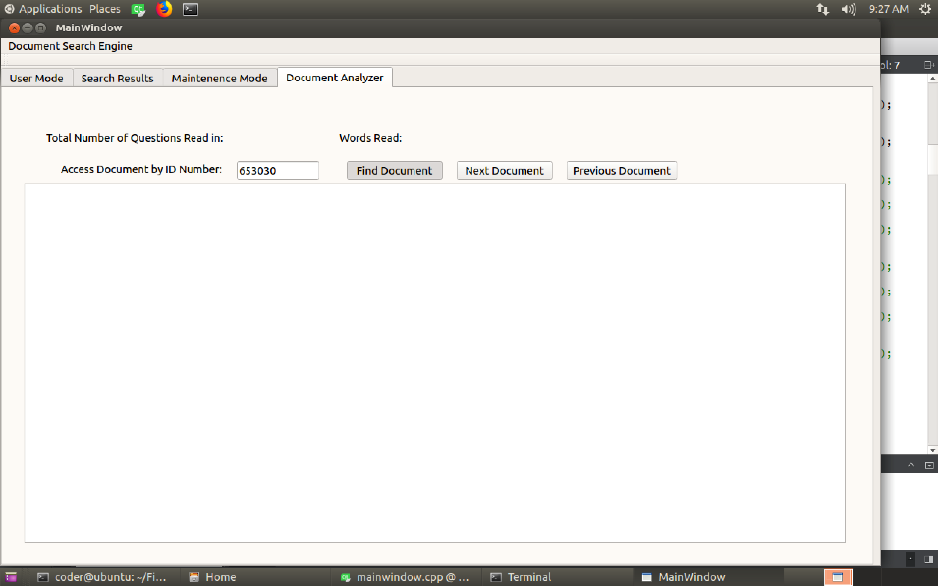
   14. Now just click find document to display the whole document
   15. 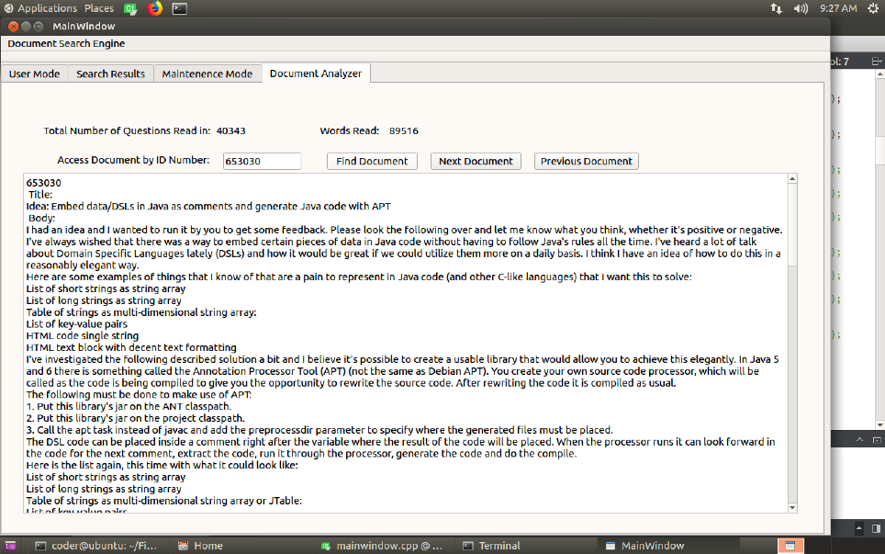

Maintenance Mode

1. How to use
   1. 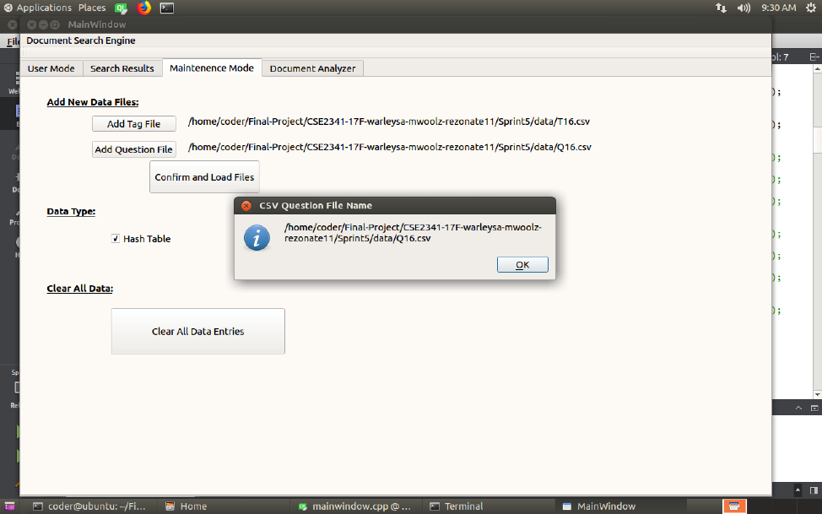
   2. Maintenance mode allows you to add more files, both question and tag, choose the data structure you utilize as an index and clear all data entries in the index. Just hit the respective button.